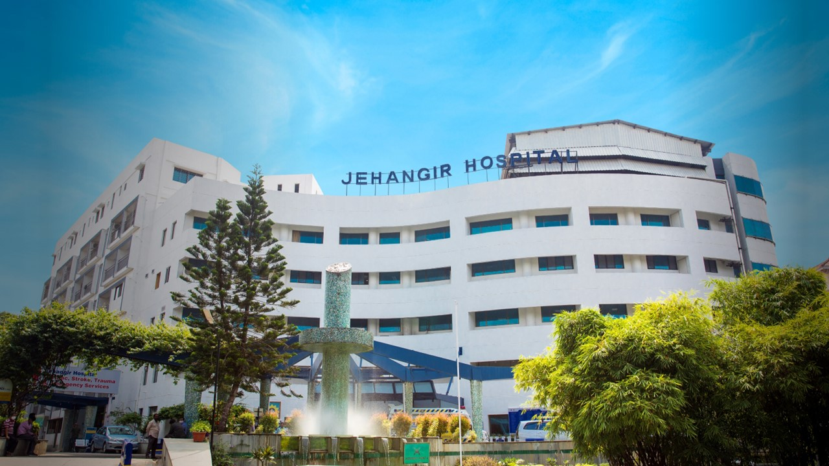
Jehangir Hospital (JEHANGIR HOSPITAL), Pune: Construction of proposed Road and Diversion of Services (Package 1)
Expression of Interest (EOI) for shortlisting the CIVIL & MEP Contractor for the construction of proposed Road and Diversion of Services (Package 1) in Jehangir Hospital (JEHANGIR HOSPITAL) premises at 32, Sassoon Road, Pune.

Objective of this EOI document:
The objective of this EOI document is an invitation to submit Expression of Interest to shortlist an agency for provision for construction & development of proposed Road and Diversion of Services (Package 1) in Jehangir Hospital campus at 32, Sassoon Road, Pune.
This EOI is not an offer to contract, nor should it be construed as such; it is a definition of specific requirements and an invitation to recipients to submit a response addressing such requirements. Issuance of this EOI, your preparation and submission of a response, and the subsequent receipt and evaluation of your response by JEHANGIR HOSPITAL do not commit JEHANGIR HOSPITAL to award a contract to anyone even if all of the requirements stated in the EOI are met.
JEHANGIR HOSPITAL reserves the right to make no shortlisting and/or selection and enter into no agreement as a result of this EOI. Only the execution by JEHANGIR HOSPITAL of a written contract will obligate JEHANGIR HOSPITAL in accordance with terms and conditions contained in such a contract.

Confidentiality and Disclaimer:
This EOI document contains proprietary information and is confidential to JEHANGIR HOSPITAL. No part of the EOI document or its attachments, annexures, etc. may be reproduced, in whole or in part, unless specifically required for your internal use in responding to this EOI document. This document is protected by copyright. Unauthorized disclosure of the EOI document or its contents, or failure to observe other requirements contained in this document will result in your disqualification from further consideration.
All proposals, presentations and supporting materials submitted in response to this EOI document will be treated with confidentiality and used for the purpose of selecting a Civil & MEP Contractor for this project.
The submission and receipt of proposals does not obligate JEHANGIR HOSPITAL in any way. JEHANGIR HOSPITAL shall not be liable for any costs incurred by Bidders in the preparation, presentation or any other aspect of the proposals received by reason of this request, nor is JEHANGIR HOSPITAL obligated to negotiate separately with any sources whatsoever in any manner necessary to serve Bidder's best interests.
JEHANGIR HOSPITAL makes no representation, implied or express, that it will accept and approve any responses/proposal submitted. Any and all contracts which result from this EOI document shall be non-exclusive, non-commitment, as ordered agreements.
While due care has been taken in the preparation of this EOI document, JEHANGIR HOSPITAL will not be held responsible for any inaccuracy in the information provided herein. The Bidder must apply its own care and conduct its own investigation and analysis regarding any information contained in the EOI document and the meaning and impact of that information.

Introduction about project:
JEHANGIR HOSPITAL is an established and prominent name in the healthcare sector in Pune and western Maharashtra region. It has a legacy of more than 79 years in the sector serving people of region and from outside India as well.
As part of its capacity enhancement exercise, JEHANGIR HOSPITAL proposes to construct a Road having concrete pavement and involving diversion works of existing service lines. The work is to be carried out to facilitate the construction of New IPD Tower as a part of Hospital capacity expansion.
JEHANGIR HOSPITAL invites Expression of Interest (EOI) from the eligible, qualified & interested contractors who have delivered similar brownfield developments in the Healthcare sector, for shortlisting for the delivery of construction of the road, diversion of the services and supply and installation of Sewage Treatment Plant setup.
List of Annexures to EOI:
- Annexure-1: Preliminary details about the project.
- Annexure-2: Broad scope of project works for the Construction.
- Annexure-3: Additional scope of project works, that could be included in the agency’s main scope of work.
- Annexure-4: The pre-qualification document, that needs to be filled-in and submitted by the desirous agency / Contractor, for assessment & shortlisting.
- Annexure-5: Drawings related to Civil & MEP Works.
Interested agency is requested to provide sufficient and relevant information demonstrating that they meet the specified eligibility criteria and have the required qualifications & experience to deliver the project in all respect, by filling-in & submitting the Annexure-4.
Based on the information that is submitted by the desirous agency / contractor (in Annexure-4), assessment of the participating agencies would be undertaken by Jehangir Hospital for shortlisting the agency most suitable for the proposed development.
The RFP (request for proposal) cum Design Brief document would be shared ONLY with the shortlisted agencies. JEHANGIR HOSPITAL reserves the right to cancel the entire EOI & RFP process and/or to issue or not the RFP to any or the shortlisted agency. Jehangir Hospital reserves the right to cancel any or all the offers without assigning any reason thereof.
Interested agencies are encouraged to visit the Jehangir Hospital premises & the specific location of the proposed project to get themselves acquainted with the site, its surroundings, its limitations & constrains, so that the response to the EOI (& RFP if it shared with the shortlisted agency) is after proper & clear understanding of the project expectations & constraints.
Any queries related to the proposed project will have to be directed to the below mentioned team.
Mr. Sanjay Rajput, Projects Head, 88888 21039

Annexure-1: Preliminary details about the proposed Road Construction & Services Diversion Works:
- Construction of Cement Concrete Road Works at Jehangir Hospital Campus as per detailed drawings and specifications
- Diversion of existing storm water service lines including construction of Sump Pits of required capacity as per drawings and specifications.
- Diversion of existing drainage lines including construction of Sump Pits of required capacity as per drawings and specifications.
- Supply and installation of Street Lights as per detailed drawings and specification including cost of Civil Works
- Project timelines:
  - Start date of project: 18th July 2026
  - Duration: 4 months
- Site enabling works:
  - Water & power would be provided free of cost by Jehangir Hospital.
- Site constraints & limitations:
  - Very limited space for material storage.
  - NO space provision for labour accommodation inside the campus.
  - Restricted works hours for noise-making activities and for movement of material to & from the campus.
  - Complete coordination with the JEHANGIR HOSPITAL security & maintenance teams for working hours and Safety & security of the project works.
  - Safety & security of the project works, and the labour/staff deployed by agency during construction period would be agency’s responsibility.
  - Maintaining cleanliness & hygiene at site would be agency’s responsibility and it would very crucial for hospital environment, and hence, it would be very strictly enforced by JEHANGIR HOSPITAL project/maintenance teams and agency will have to abide by the same.
Annexure-2: Broad scope of project works for the Civil & MEP Works under package 1:
- Construction of proposed Cement Concrete Road and Diversion of Storm Water and Drainage lines to facilitate the construction of New IPD Tower at Jehangir Hospital, Pune.
Annexure-3: Additional scope of project works, as part of campus development:
Few important items of work are likely to be included in the scope of the shortlisted agency, which are part of the larger developments in the hospital campus, like:
- Shore Piling for in & Out Ramp Protection
- Demolition of Existing Structures

Confirmation to this regard would be provided to the shortlisted agency well in advance before award of the main work.

